**Cluster Centers**

The code used in creating cluster centers is given below:

**Creating WSSE for clusters having size 2 to 32.**

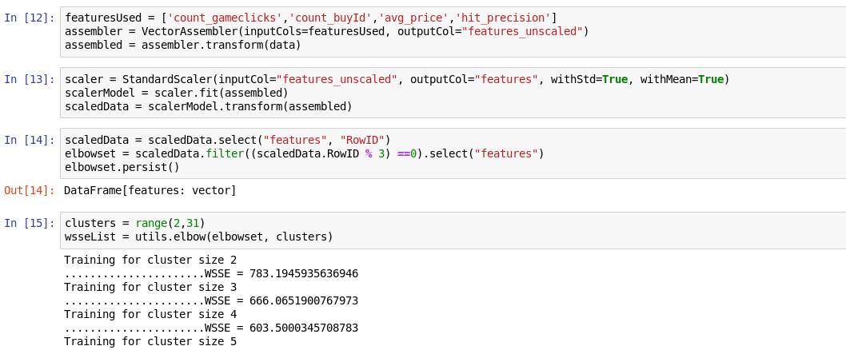

**Elbow method shows 10 is a good number of clusters to use :**

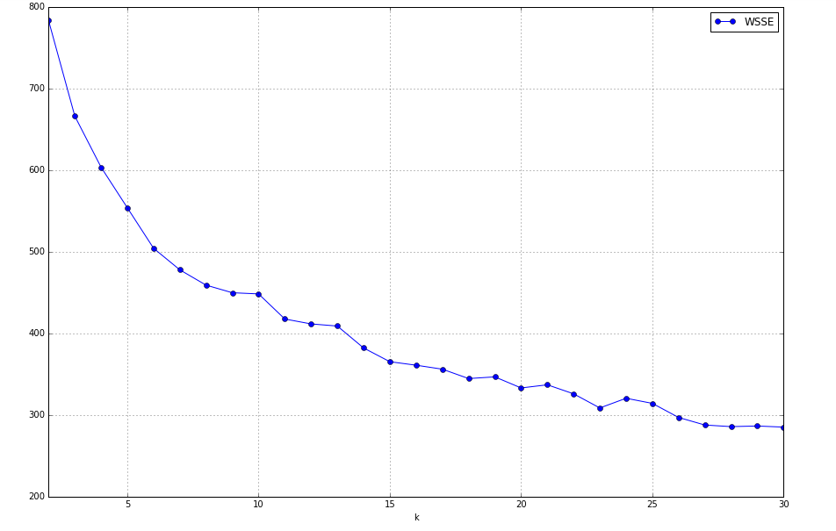

Cluster centers formed are given in the table below

|  |  |
| --- | --- |
| **Cluster #** | **Center** |
| 0 | 0.10723134, 1.980912778, -0.09852266, -0.21182086 |
| 1 | 0.45816666,-0.37126505, -0.51606561, -0.75776555 |
| 2 | -0.38066003, 0.54586233, -0.24610162, 0.87695128 |
| 3 | -0.38471387, -0.75868591, -0.4727514, 0.65651244 |
| 4 | -1.17148452e-01, -2.74952690e-01, 1.69343828e+00, 1.03948322e-03 |

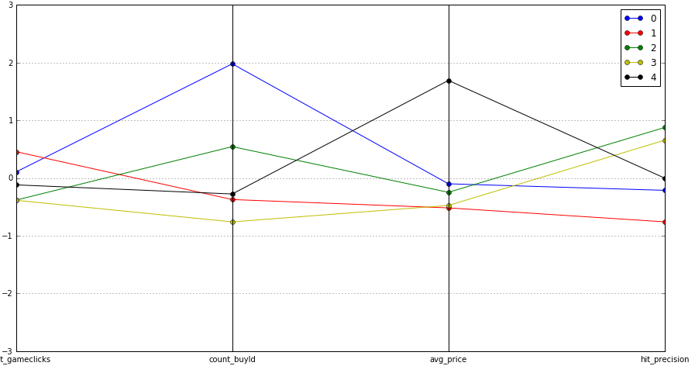

**These clusters can be differentiated from each other as follows:**

Cluster 0 has the highest number count_buyID, but we can notice the revenue is coming most from cluster 4.

Cluster 1 members are most playing . We can therefore notice they have the less precision. Also , Cluster 1 members spend a lot of time playing but they are NOT giving revenue.

Cluster 3 members who plays in a moderate way , have more hit precision .

**Below you can see the summary of the train data set:**

<SCREENSHOT AS FROM JUPYTER NOTEBOOK>

